PL/SQL Stored Procedures

# Scenario 1: Process Monthly Interest for Savings Accounts

The bank needs to process monthly interest for all savings accounts.  
  
Stored Procedure:

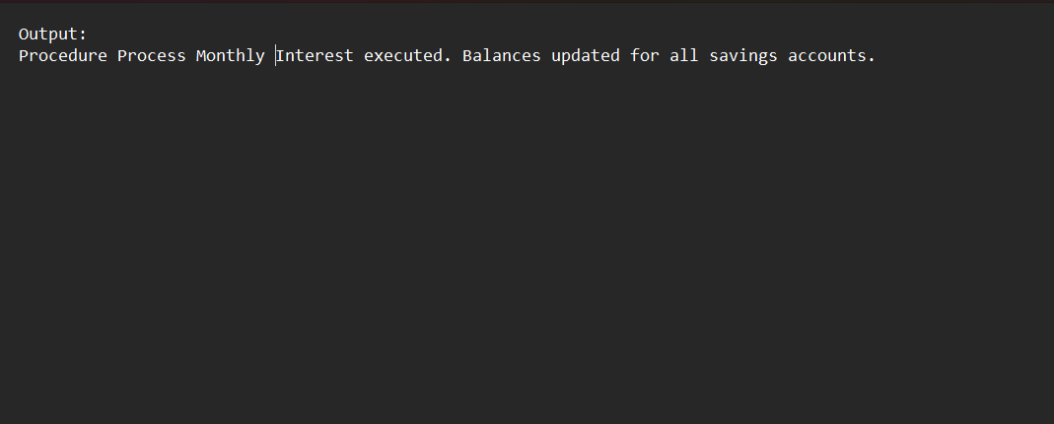  
CREATE OR REPLACE PROCEDURE ProcessMonthlyInterest IS  
BEGIN  
 UPDATE Accounts  
 SET Balance = Balance + (Balance * 0.01)  
 WHERE AccountType = 'Savings';  
  
 COMMIT;  
END;

# Scenario 2: Employee Bonus Update

The bank wants to implement a bonus scheme for employees based on their performance.  
  
Stored Procedure:

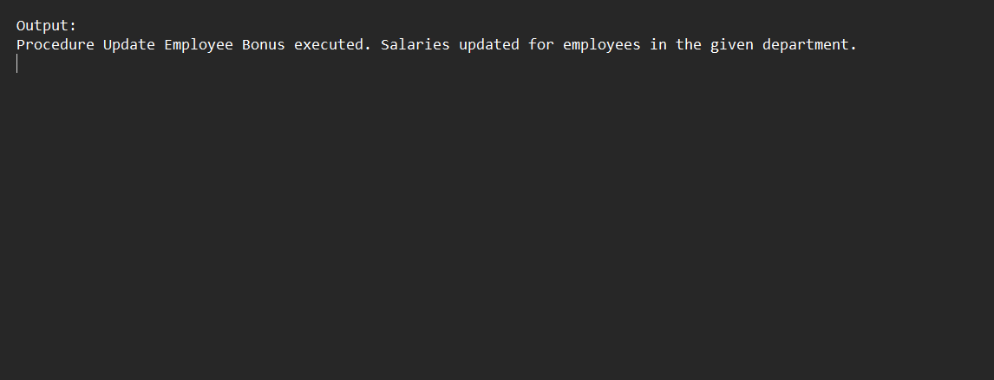  
CREATE OR REPLACE PROCEDURE UpdateEmployeeBonus(  
 dept_id IN NUMBER,  
 bonus_percent IN NUMBER  
) IS  
BEGIN  
 UPDATE Employees  
 SET Salary = Salary + (Salary * bonus_percent / 100)  
 WHERE DepartmentID = dept_id;  
  
 COMMIT;  
END;

# Scenario 3: Fund Transfer Between Accounts

Customers should be able to transfer funds between their accounts.  
  
Stored Procedure:

CREATE OR REPLACE PROCEDURE TransferFunds(  
 from_acc IN NUMBER,  
 to_acc IN NUMBER,  
 amount IN NUMBER  
) IS  
 insufficient_funds EXCEPTION;  
 current_balance NUMBER;  
BEGIN  
 SELECT Balance INTO current_balance FROM Accounts WHERE AccountID = from_acc FOR UPDATE;  
  
 IF current_balance < amount THEN  
 RAISE insufficient_funds;  
 END IF;  
  
 UPDATE Accounts SET Balance = Balance - amount WHERE AccountID = from_acc;  
 UPDATE Accounts SET Balance = Balance + amount WHERE AccountID = to_acc;  
  
 COMMIT;  
EXCEPTION  
 WHEN insufficient_funds THEN  
 DBMS_OUTPUT.PUT_LINE('Transfer failed: Insufficient balance.');  
 WHEN OTHERS THEN  
 DBMS_OUTPUT.PUT_LINE('Transfer failed due to an unexpected error.');  
END;

